5. L5 - Push the incremental changes to GitHub Repository through Visual Studio Code IDE

1. Create local repository

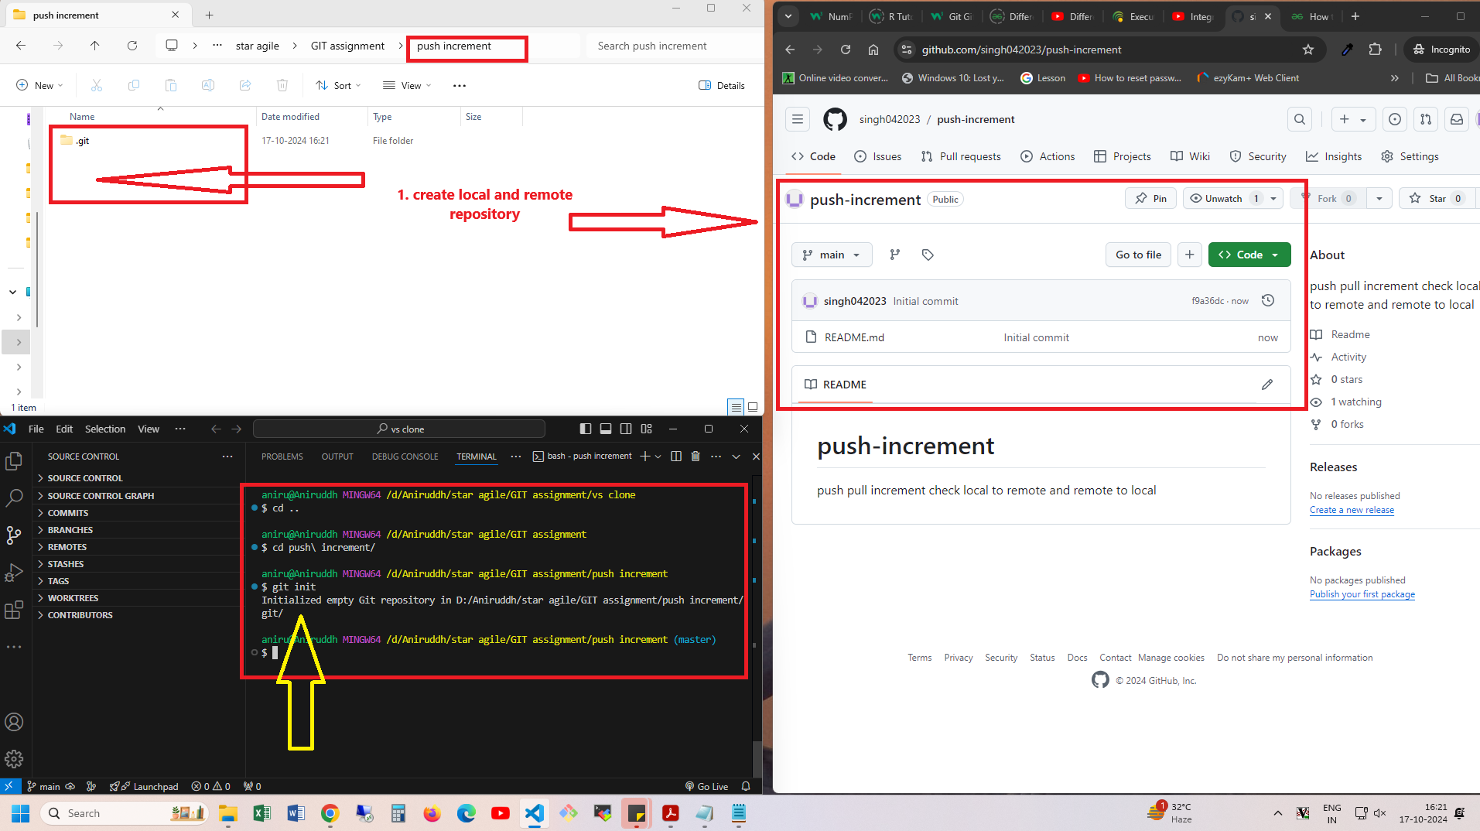

2. run $git init for create local repo

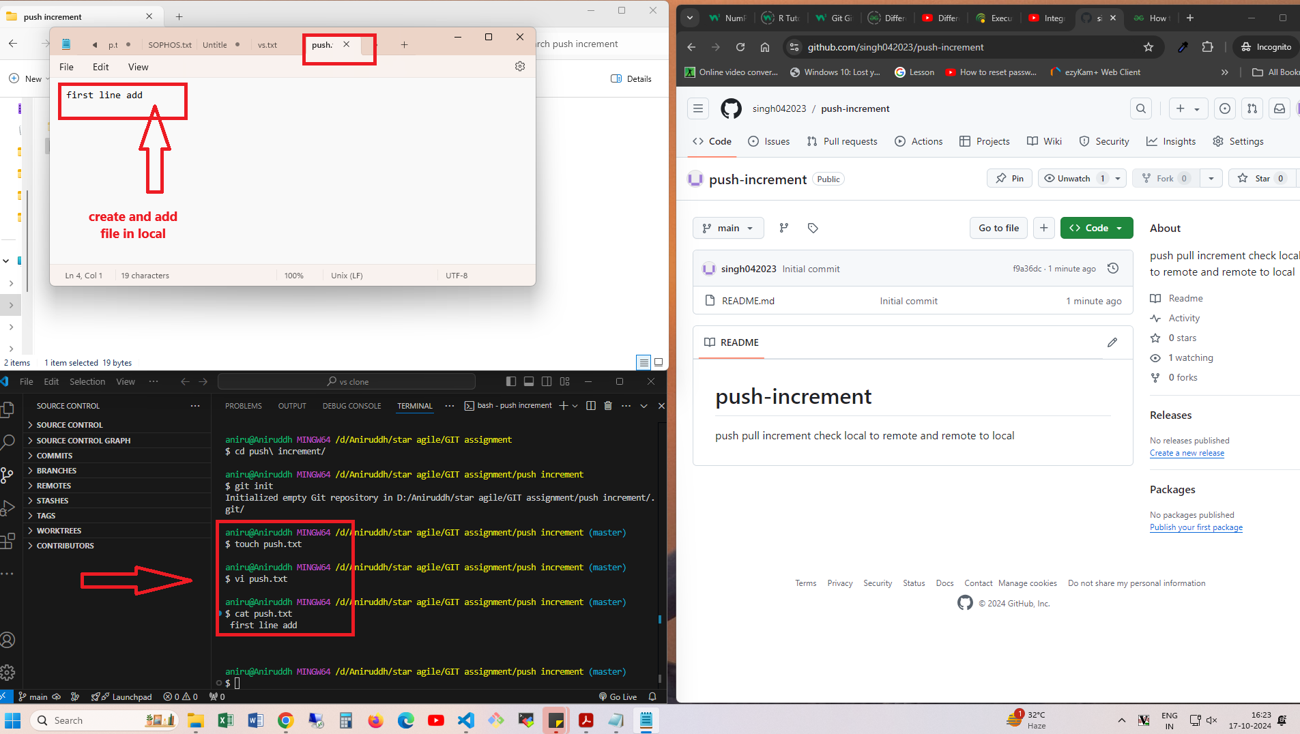

3. file add and commit

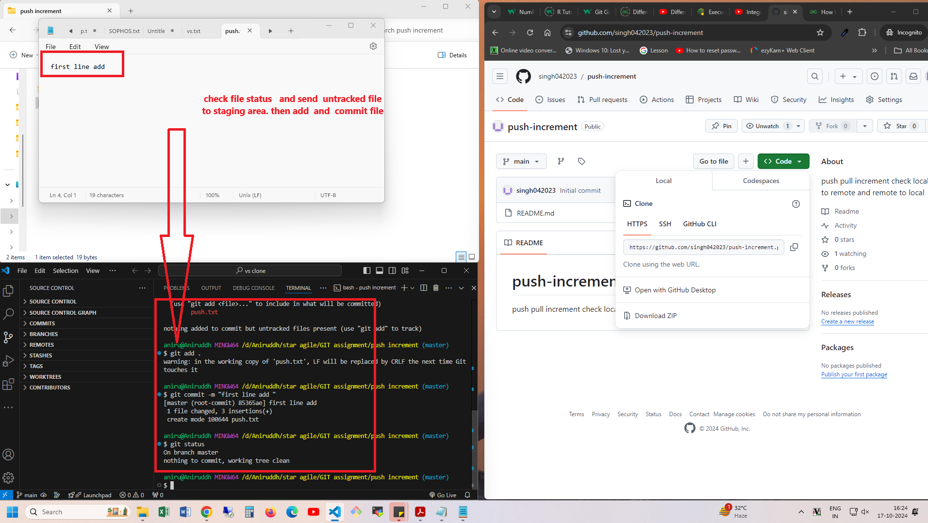

4 connect remote repository to local repository

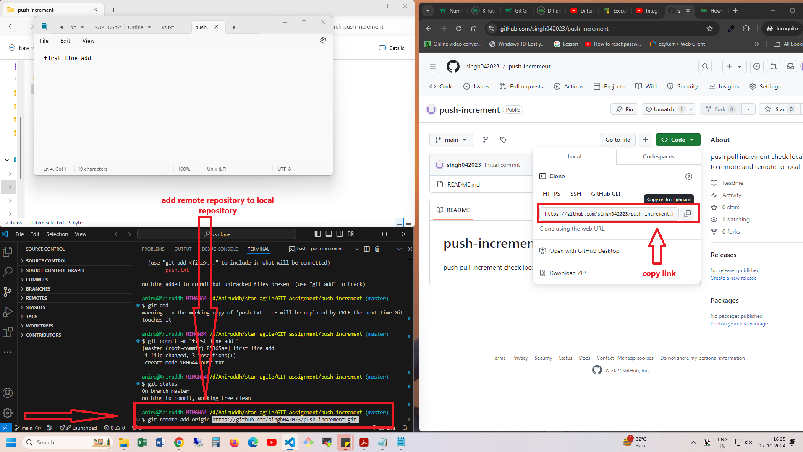

5.

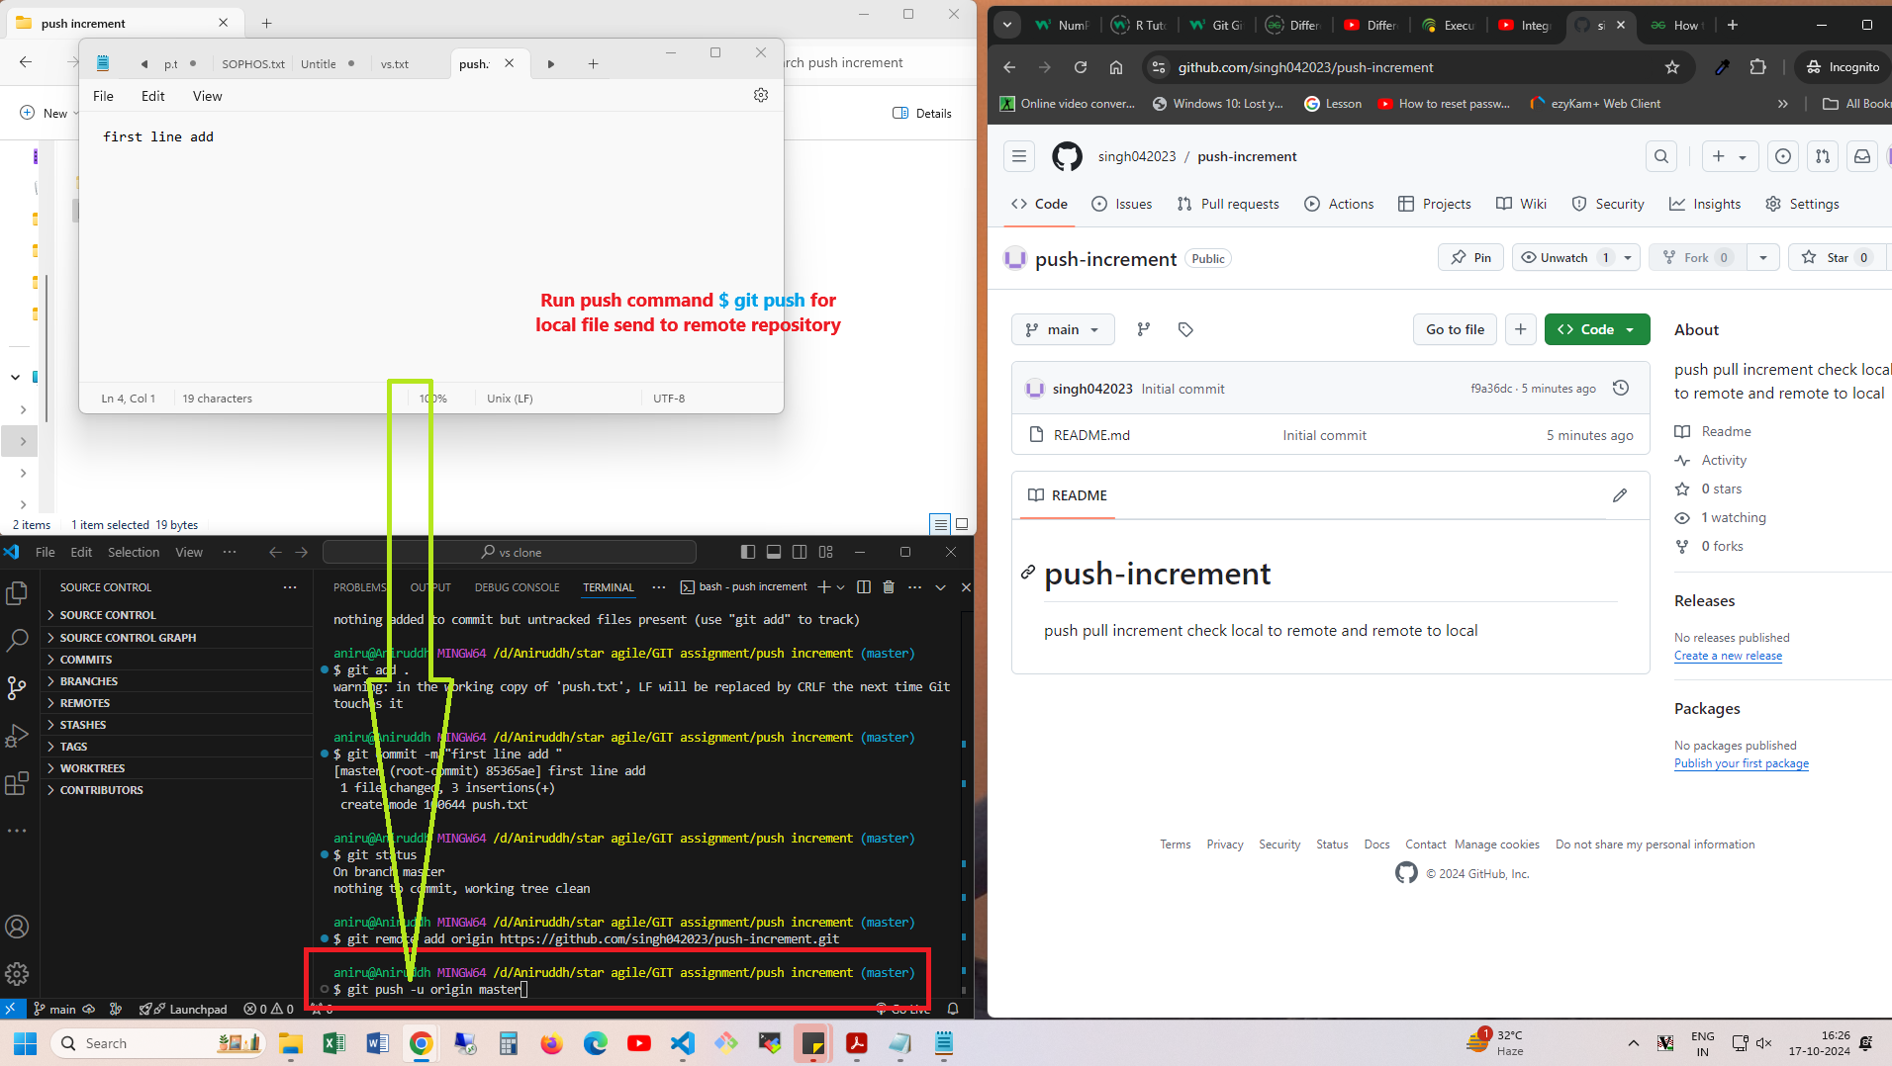

6.run push command

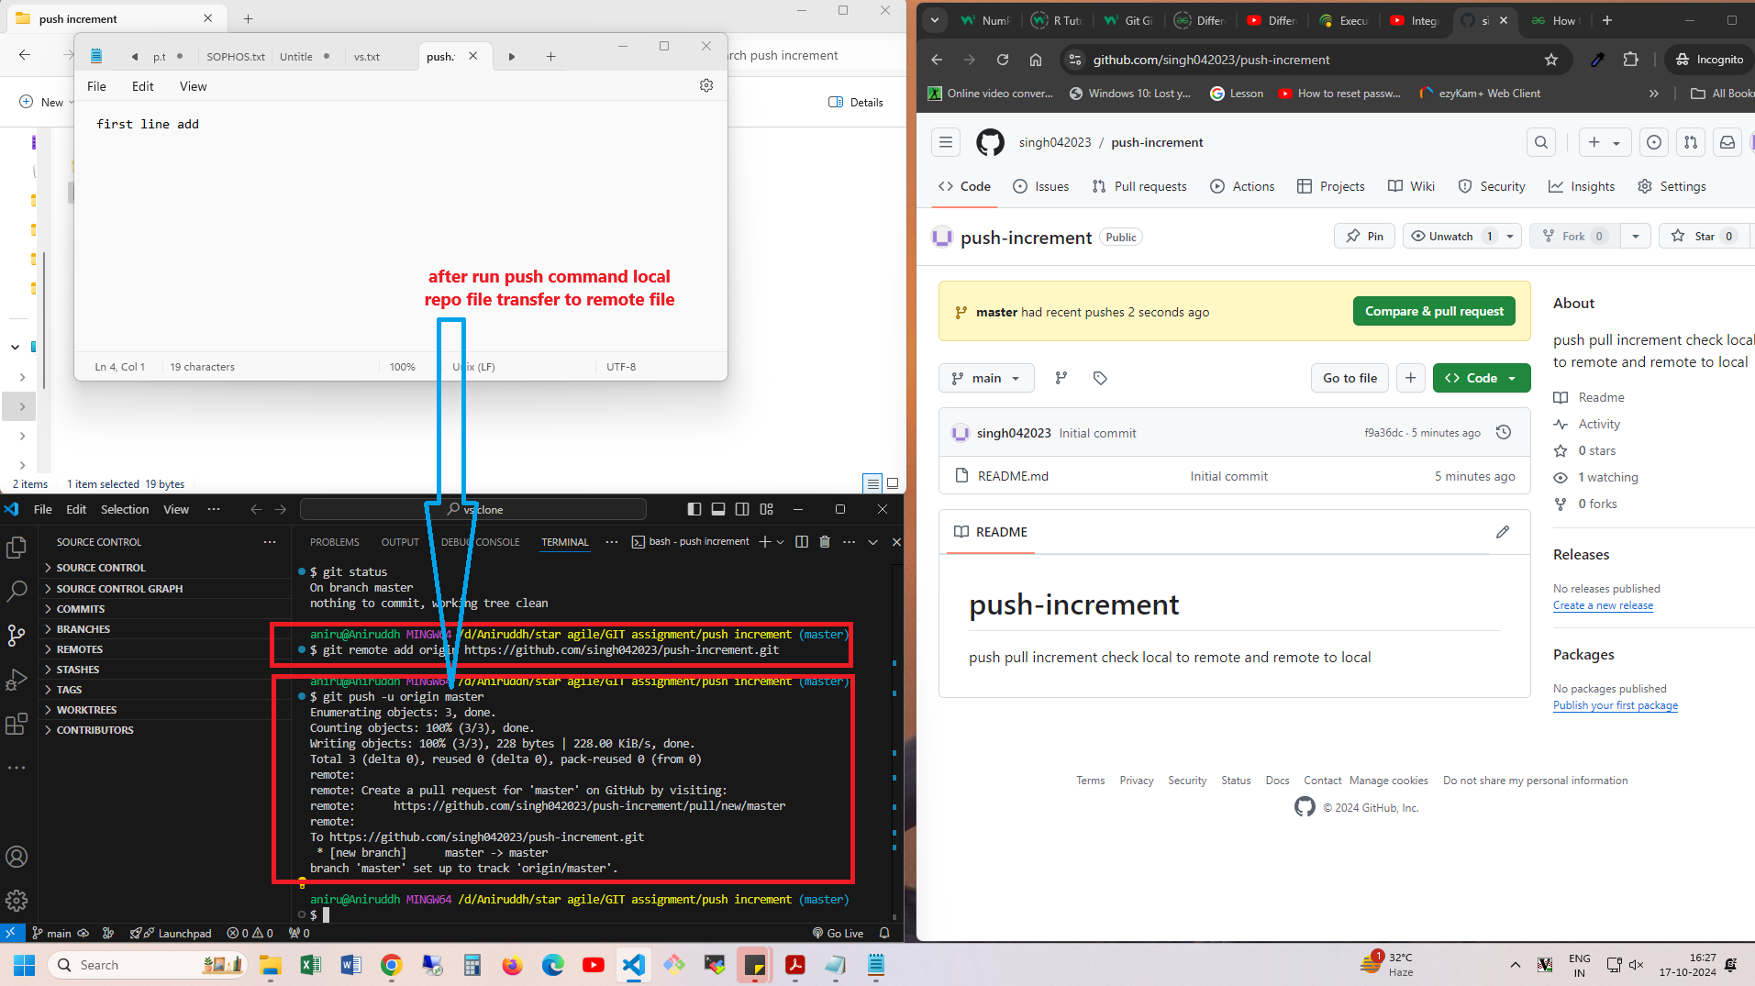

7.data send to remote complete

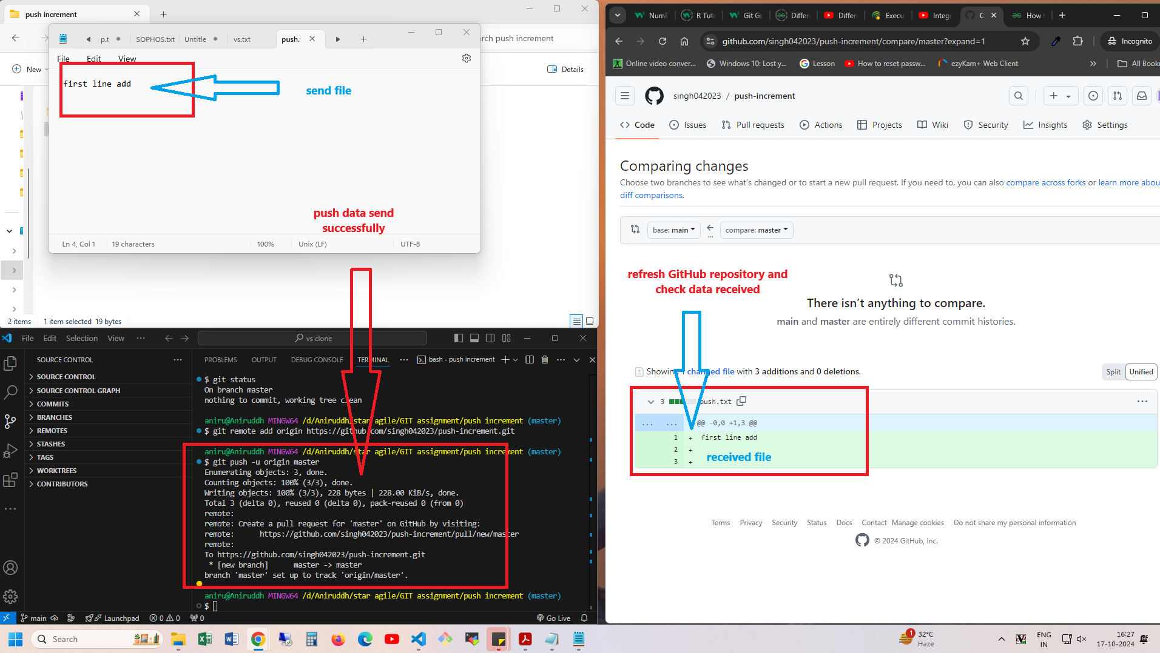

8.add second line

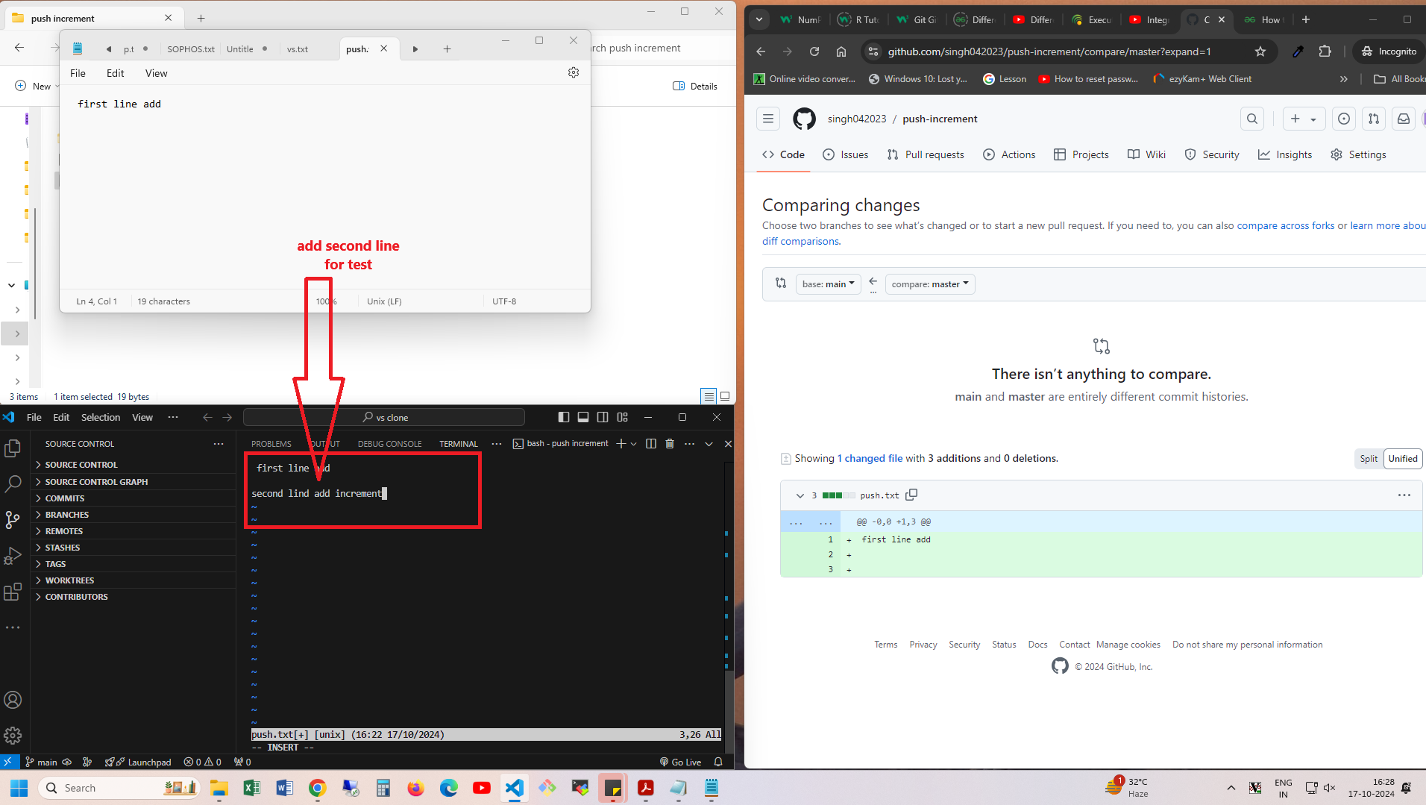

9. add new second line



9.new add and commit

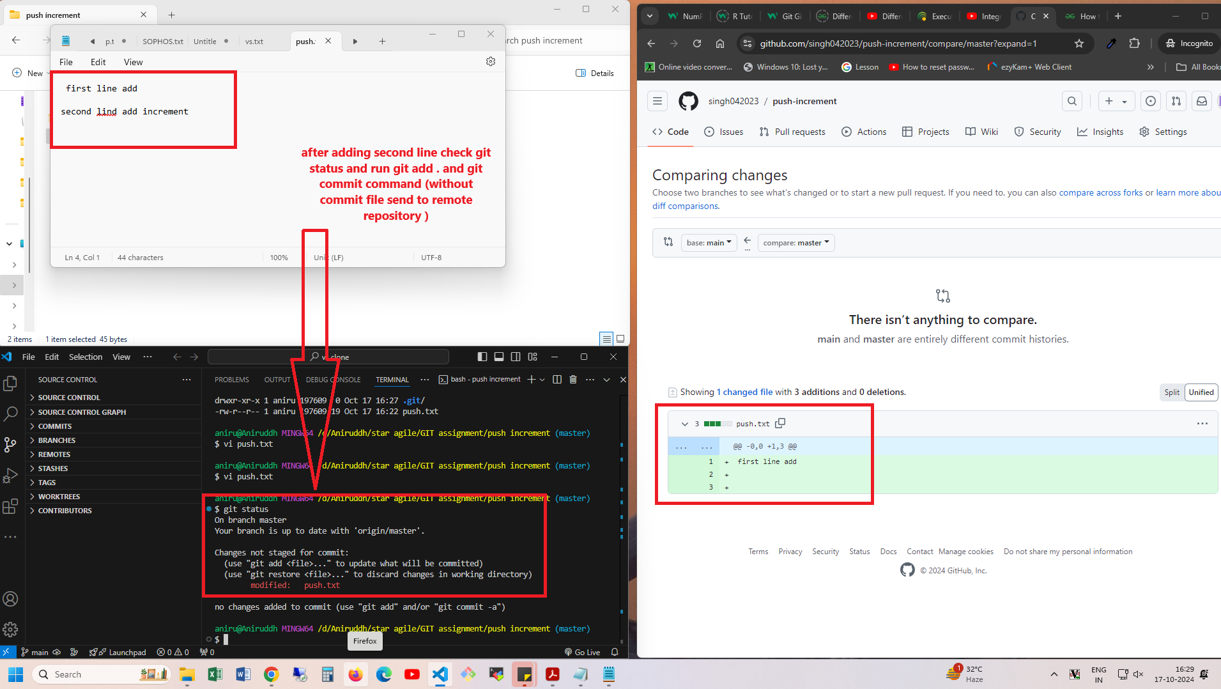

10

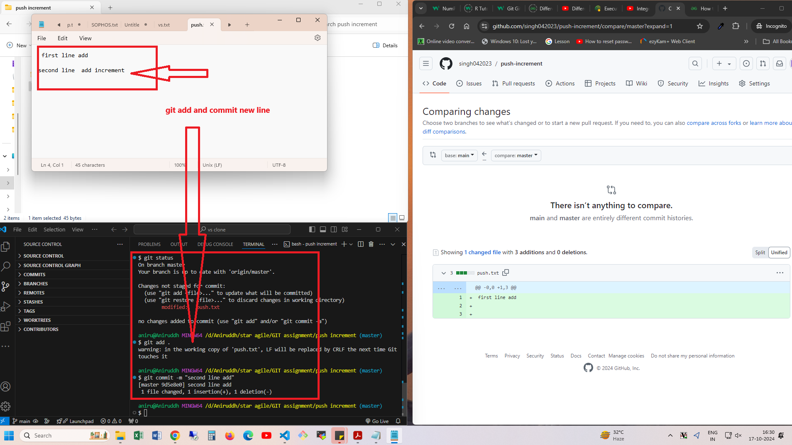

11.run push command $ push –u origin master

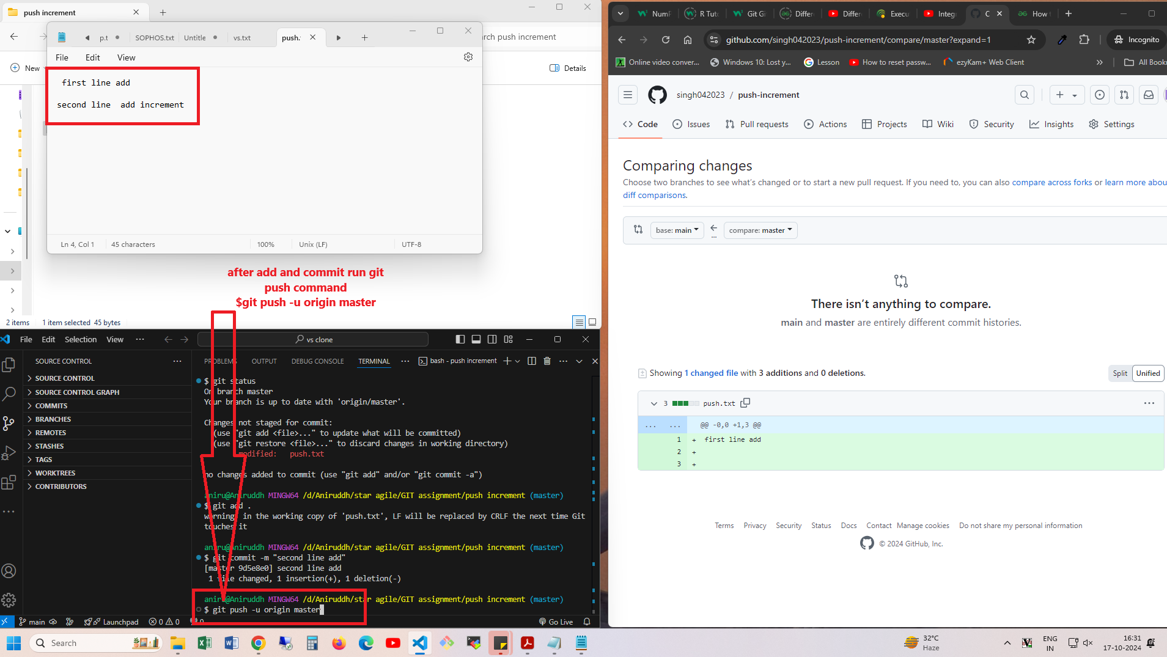

11 increment data received

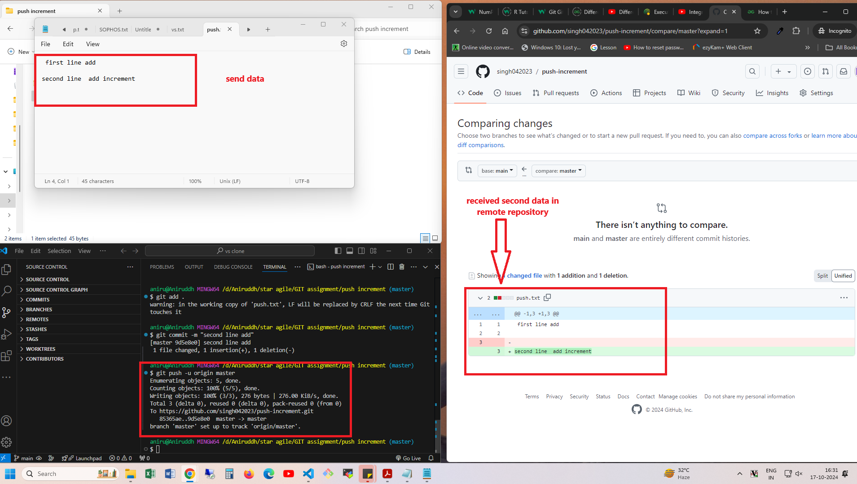

1. Create local repository run command

$git init

Check in folder one hidden file create name of .git

2. Create one repository in github and connect to local repository using command

$ git remote add origin <repository https link>

3. add new file in local repo and check status

And run git add and commit command

$ git add .

$ git commit –m “pass comment why you commit this file for future reference”

4. check again git status $ git status

5. now push file from local to remote repository using command

$ git push –u origin master (branch name in which you push to file)

6 go to github account and open repository and refresh page one new file add in repository

7 . Now one more file add and run same command

But this time git remote command not necessary to run for connecting remote repository.

For cross check step

One file add

1. Add file in local

2. Run $git add .

3. $ git commit

4. This time you can run git push command

$ git push

5. Go to remote repo and refresh you webpage now you ca see one new file received in remote.

Aniruddh Joshi